Martin’s Lab 1 Reflection

Secure Software Development – COMP 10203

Martin Chung

000790207

Lab Status:

* ApplicationUser Model: Working
* Team Model: Working
* Teams Controller is scaffolded and working properly with authentication and roles requirement
* When program starts up, it seeds the database with initial users and roles properly.
* Managers have full access and players have read only access. Unauthenticated users cannot access the Teams Controller.
* Database name on connection string is “SSD_Teams”
* ApplicationDbContext is using IdentitySystem as well as updated ApplicationUser class and Teams class.
* Database migration added properly
* Teams table is seeded at initial run of the application
* Shared layout view has been updated to link to Get action of the Teams Controller

Three things learned from the lab:

* How to scaffold new models, both with models using Identity system and models that does not use Identity system
* How to seed data into database for initial run of the application
* How to add more fields and validate user input as necessary

Three areas that needs work based on the lab:

* Application needs to automatically assign a role as a Player when new account is created
* There should not be unnecessary components, such as authenticator links, which might not work.
* When attempting to get Teams controller while unauthenticated, it redirects to login screen instead of message saying that access is denied.

Screenshots

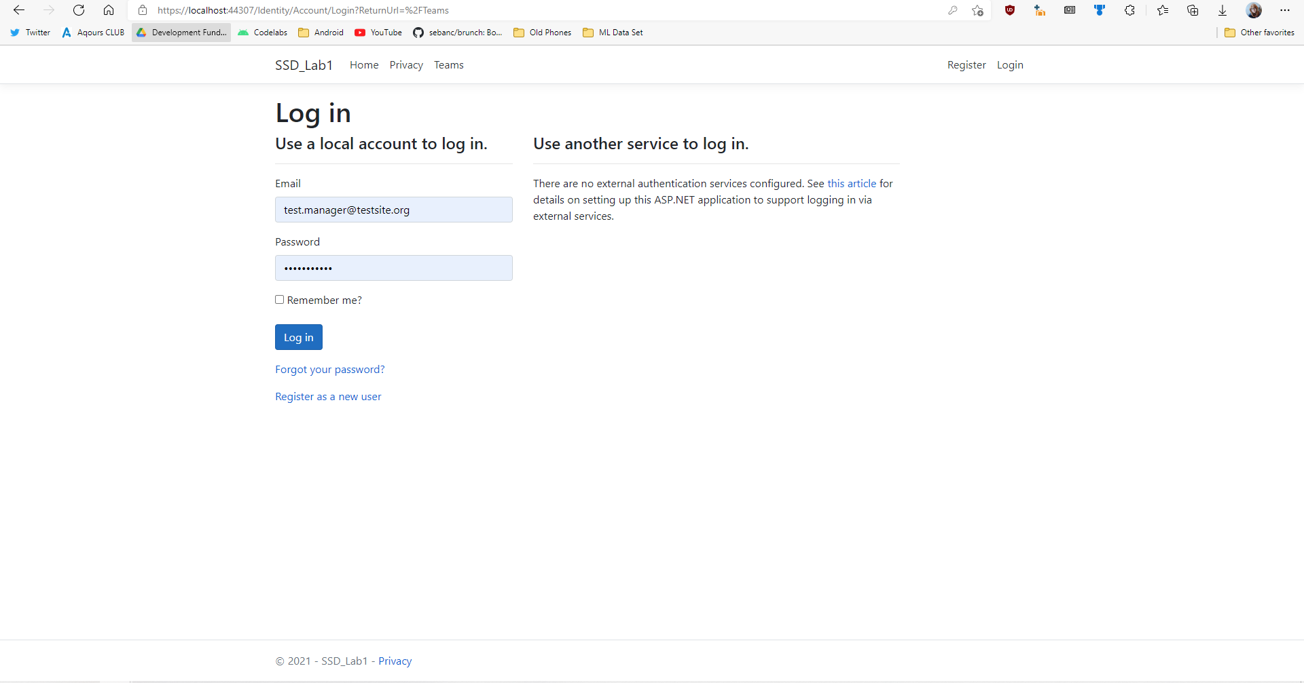When user attempts to access Teams controller while unauthenticated, application will prompt user to sign in. 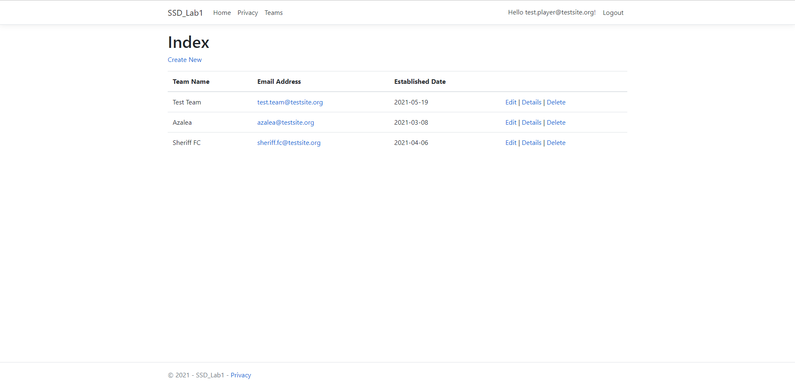

When a user access Teams controller as a player, application will show list of teams.

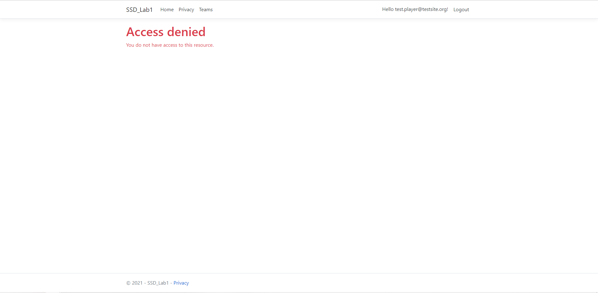

When a user attempt to access edit or delete action of the Teams controller as a Player role, application will reject access.

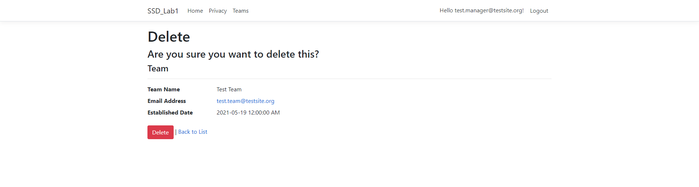

When a user access Delete function of the Teams controller as a Manager role, application will allow user to delete team data.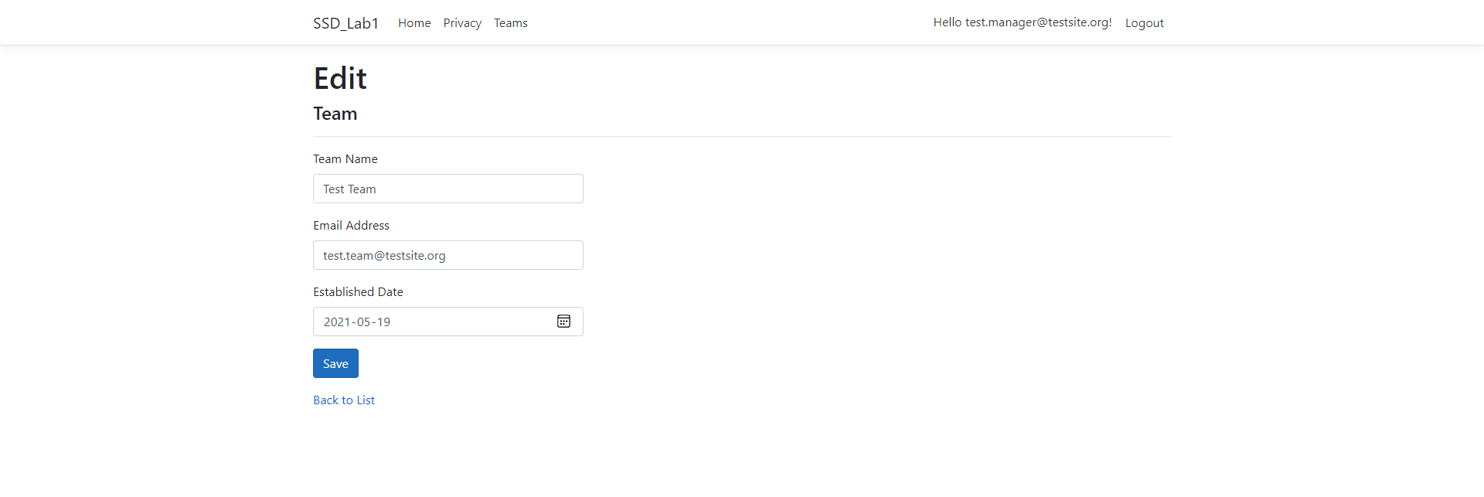

When a user access Edit function of the Teams controller as a Manager role, application will allow user to edit team data.

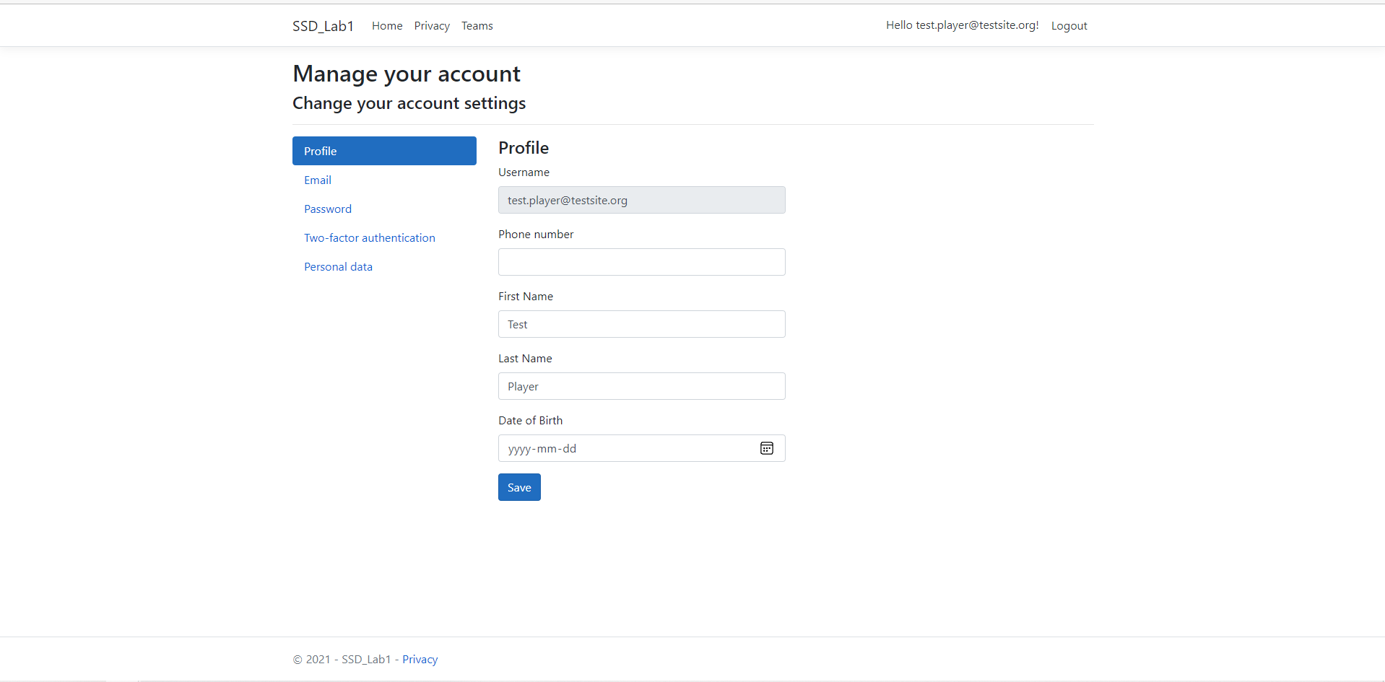

Profile page will show user’s user name (Email address), Phone number, First Name, Last Name, and Date of Birth. 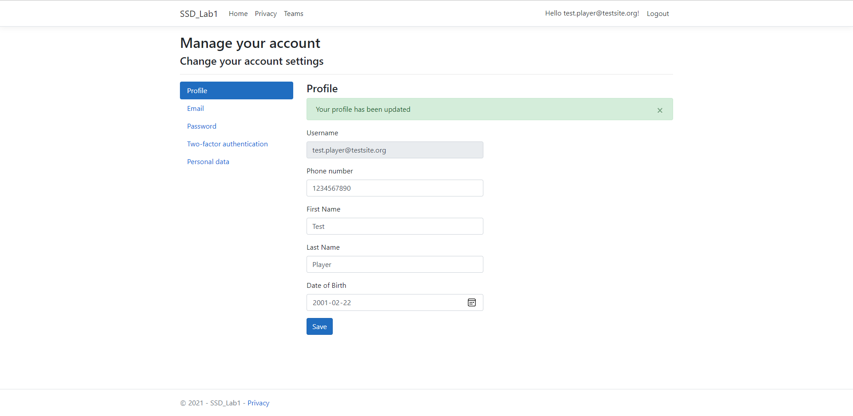

User can edit their own profile page, such as adding or editing every information.

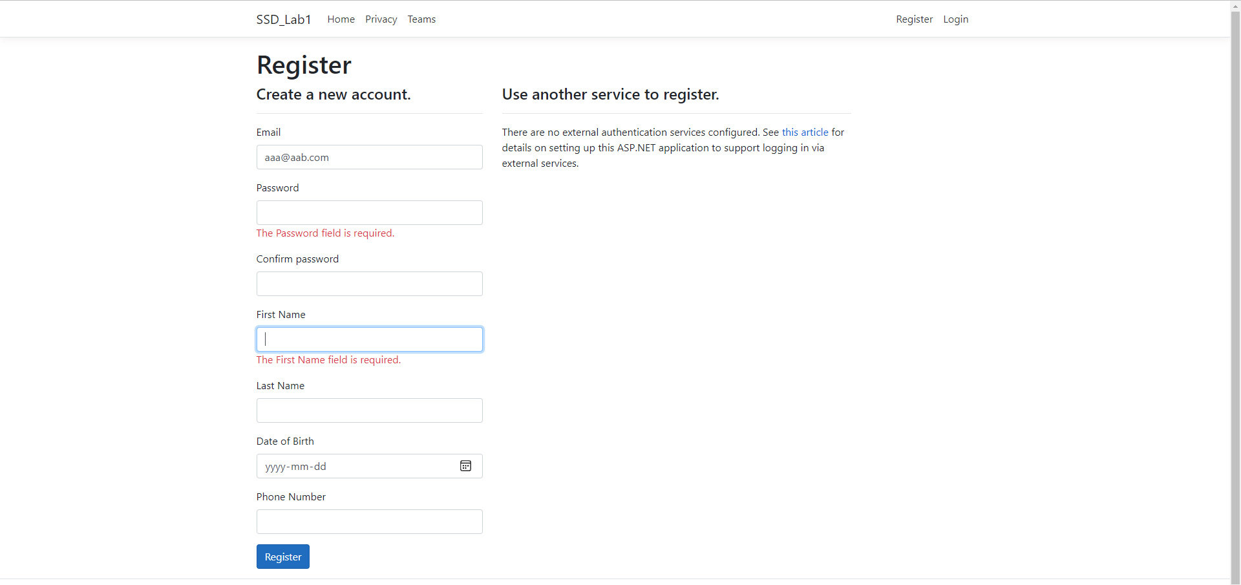

Registration form allows user to enter various data, and it will validate each data and check if required data has been entered.

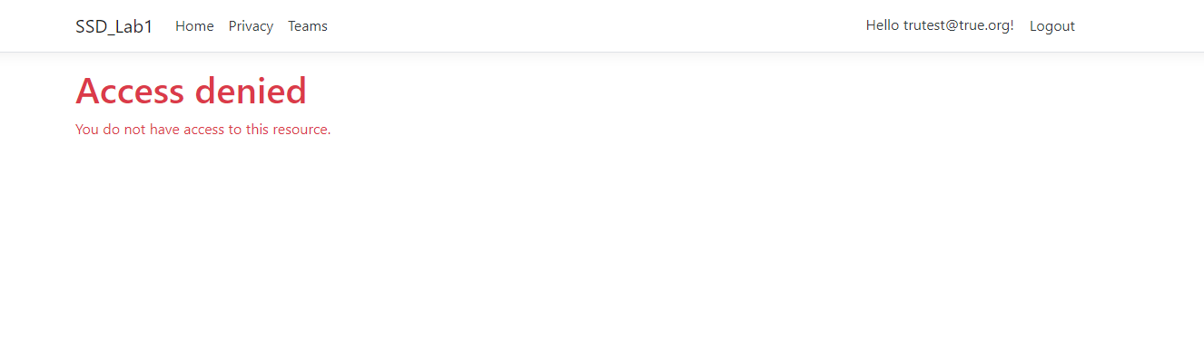

A problem that any new user created will not even have read access for Teams controller. This is because the application does not assign “Player” role by default for new user created.